**BLAST Report of the PAX1 Gene and Protein**

The human PAX1 gene produces the PAX-1 protein which is expressed in the sclerotome. It belongs in the paired box family of transcription activators, and it plays an important role in fetal development and embryogenesis. It may also be necessary for the development of the spine. It is silenced by methylation in ovarian and cervical cancers, and mutations of this gene could lead to spine defects.

I would expect to find this gene and protein in similar human-looking organisms such as chimpanzees and gorillas since the BLAST results indicate a highly similar score compared to the actual human PAX1 gene. Chimpanzees and gorillas undergo very similar embryological development as humans, so this protein is likely to play an equally important role in the embryo stages of these two organisms. For example, the gorilla only has 88 different nucleotides compared to a total of 5354 in humans. As well, homologs of this gene could even be found on most mammals with similar spine shapes such as dogs, cows and mice.

When blasted the protein sequence of PAX1, similar results showed up as with the nucleotide blast. Organisms that were high up on the list included the chimpanzee, gorilla, and the gelada. The chimpanzee only had 4 out of 534 amino acids that was different from that of a human PAX-1 protein. However, the gorilla was not found until near the middle of the list, which means that in the gorilla, the gene was nearly identical, but the protein was not. The fast-minimum evolution tree, according to Grishin (I am uncertain of what this means), shows that although the predicted gorilla PAX-1 isoform is only one branch away from the human isoform, the species that has the closest confirmed isoform is the chimpanzee.

It is possible to find the same gene but not the protein in two organisms because sometimes the gene is silenced by transcription factors, where it cannot code into proteins. Many organisms do have similar PAX-1 genes, but seemingly minor differences may produce different amino acids which make up different proteins. The gorilla is an example, where the PAX1 gene is much more like human’s than the PAX-1 protein.

The gene is found in most of the organisms I tested, so I would conclude that this gene is very primitive but also very beneficial to organisms. Most mutations to the gene would probably do more harm than good, so the any major mutations would have been filtered off by natural selection, leaving the original PAX1 gene relatively unscathed while other genes mutate, causing organisms to speciate. However, it is sometimes difficult to determine the cut-off point where a gene can no longer be classified as PAX1. I would assume that at least the 100 or so organisms listed on BLAST would be considered to have the PAX1 gene.

DNA sequences are no doubt the most important area of study when it comes researching evolutionary relationships. However, comparisons between other characteristics, such as geological position, embryological development, homologous/analogous structures can be useful in providing a foundation to which DNA sequencing can further delve into. These characteristics also explain the reasoning behind natural selection and evolution, because it is the phenotypes of organisms that matter in terms of survival.

After conducting the experiment using BLAST, one of the questions that I raised was: Does the PAX1 gene and protein perform the same function in the organisms that have it? Based on several phylogenetic trees, I think the protein does perform the same function as organisms that are in the closer branches have basically the same morphology.

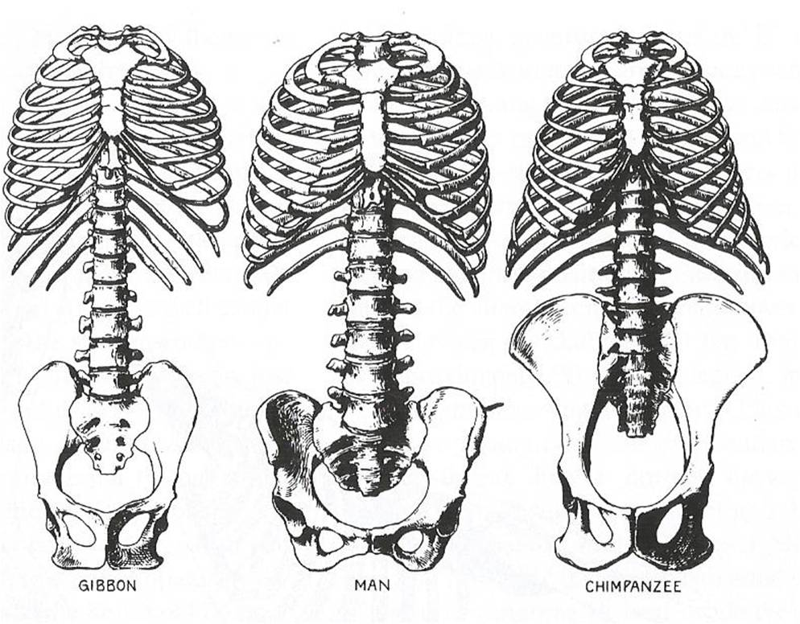

**Bibliography**

“BLAST: Basic Local Alignment Search Tool.” *National Center for Biotechnology Information*, U.S. National Library of Medicine, blast.ncbi.nlm.nih.gov/Blast.cgi.

Lumbard, James R. “Upright Walking: A Long-Standing Debate (Pt. Iv).” *What Missing Link?* WordPress.com, 29 Mar. 2014, whatmissinglink.wordpress.com/2014/03/28/upright-walking-a-long-standing-debate-pt-iv/.

“PAX1 Gene.” *ESPL1 Gene - GeneCards | ESPL1 Protein | ESPL1 Antibody*, Weizman Institute of Science, www.genecards.org/cgi-bin/carddisp.pl?gene=PAX1.